Task 1: Configure a role hierarchy and create 3 roles with different access scopes

1. Go to Setup and open the Quick Find box
2. 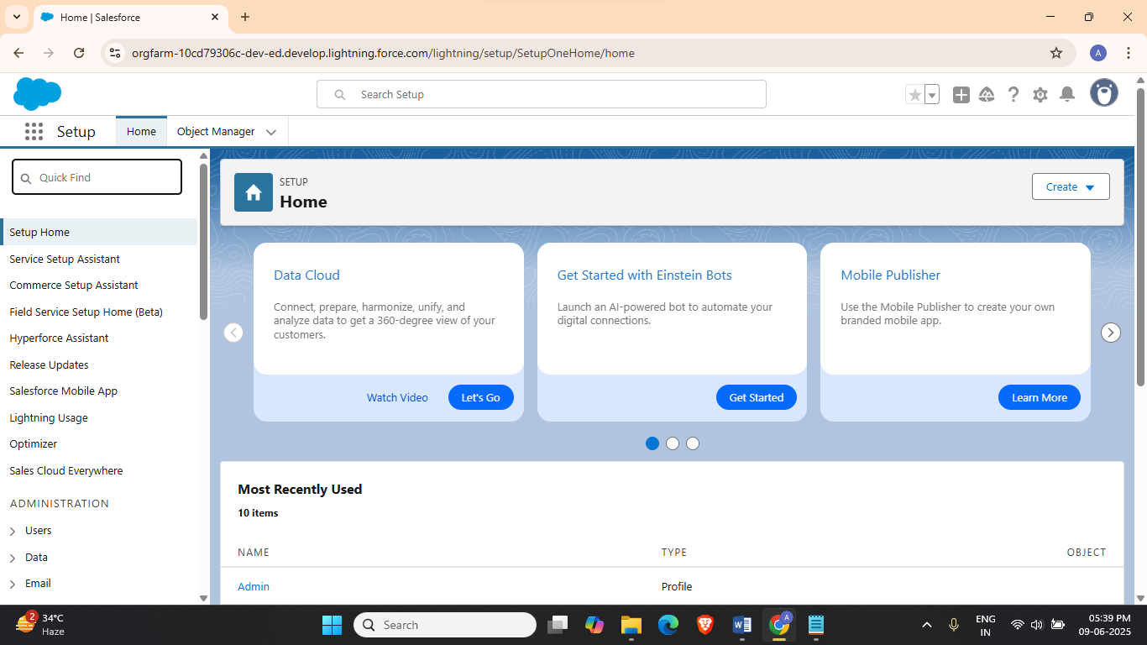
3. Search and open Roles
4. 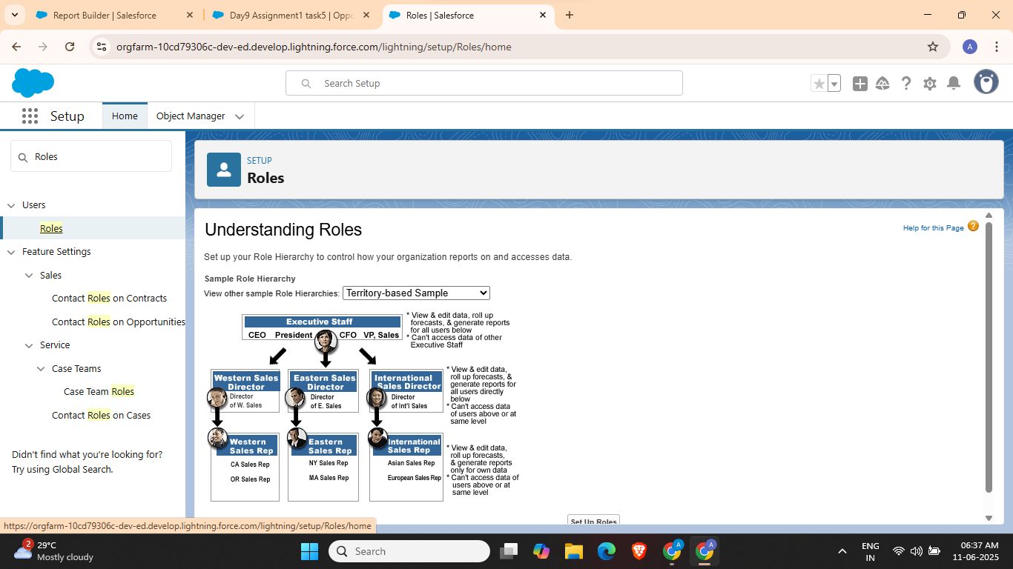
5. Click Setup Roles
6. 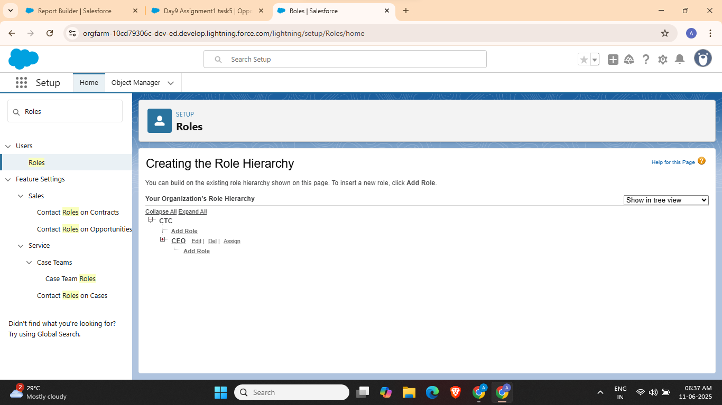
7. Click on add role under CEO
8. 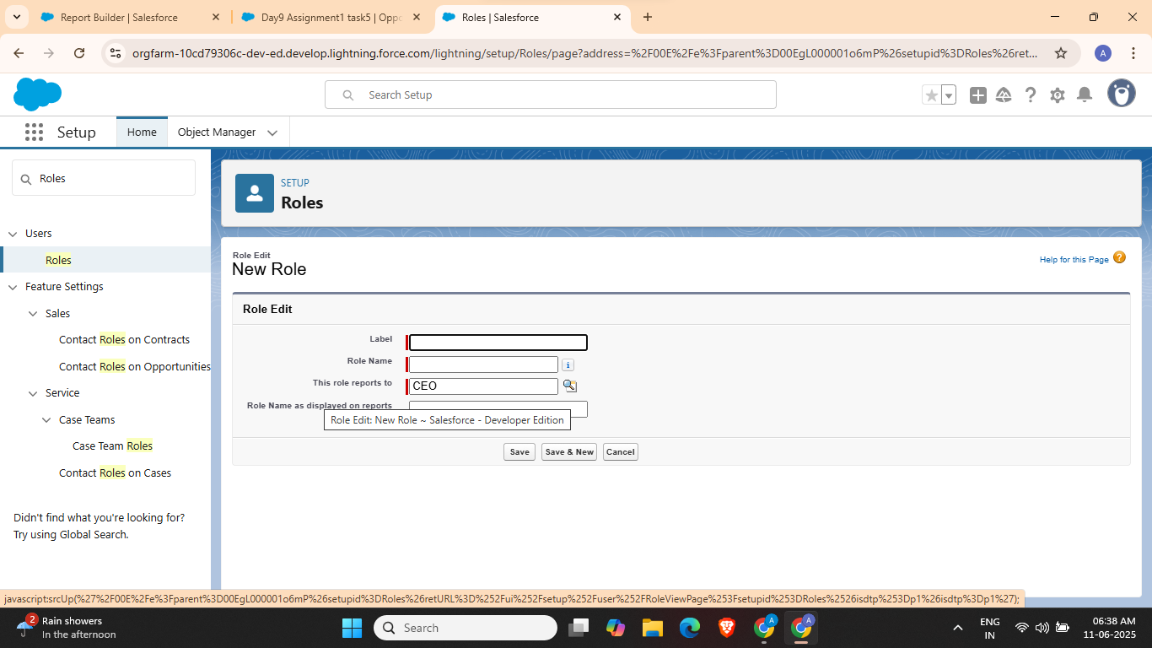
9. Now create 3 roles
10. 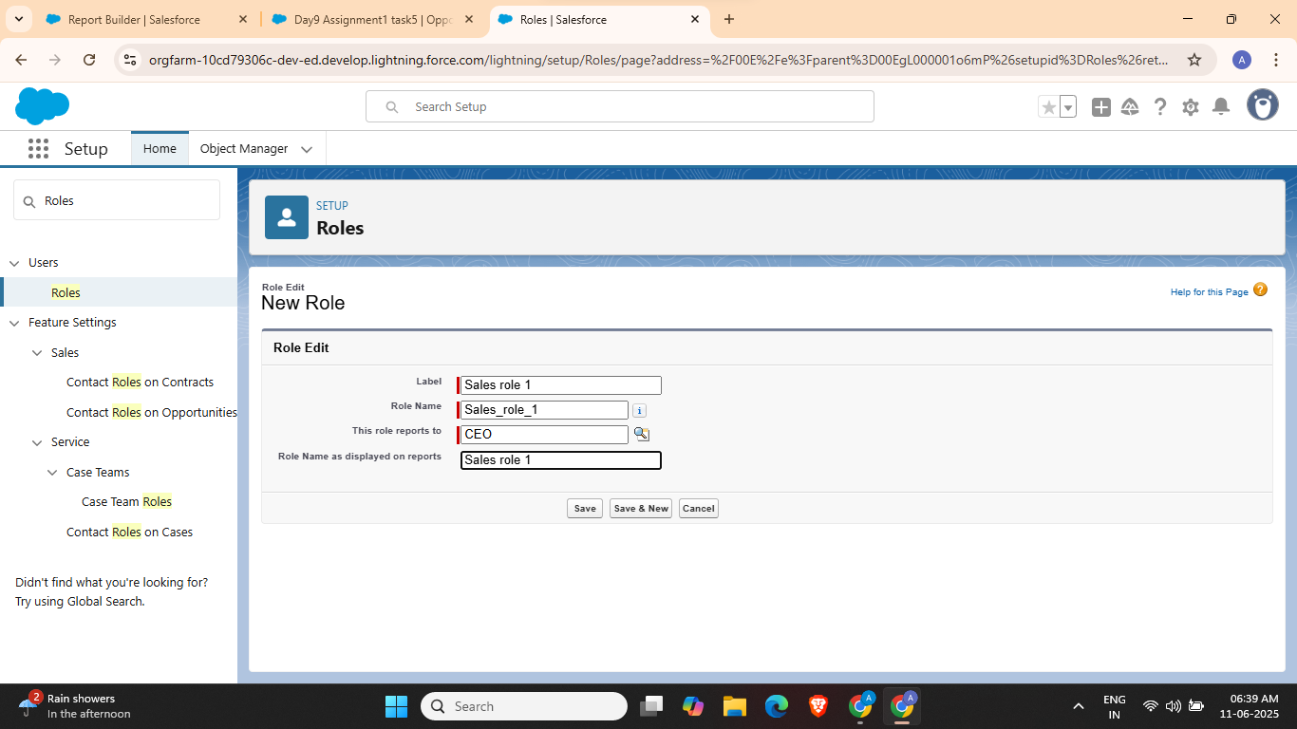
11. 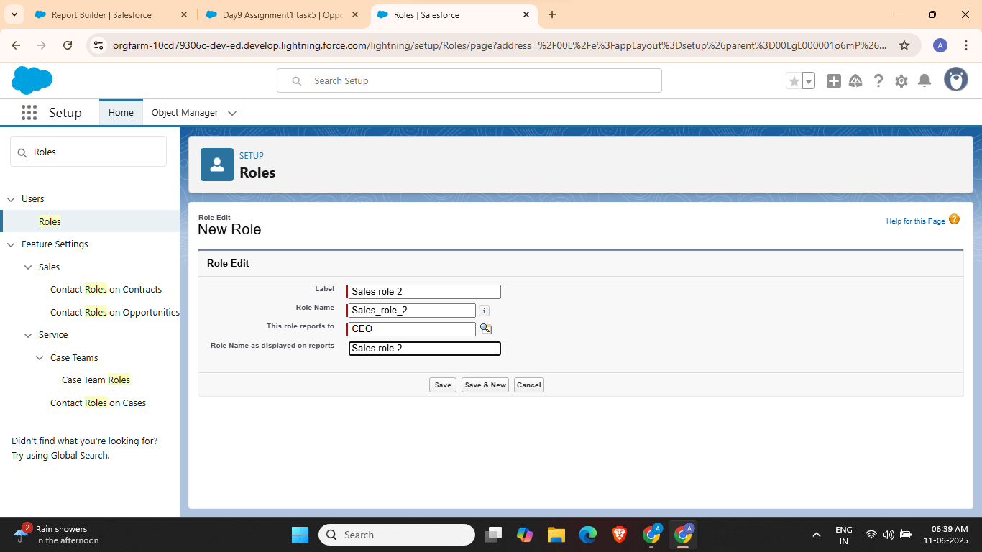
12. 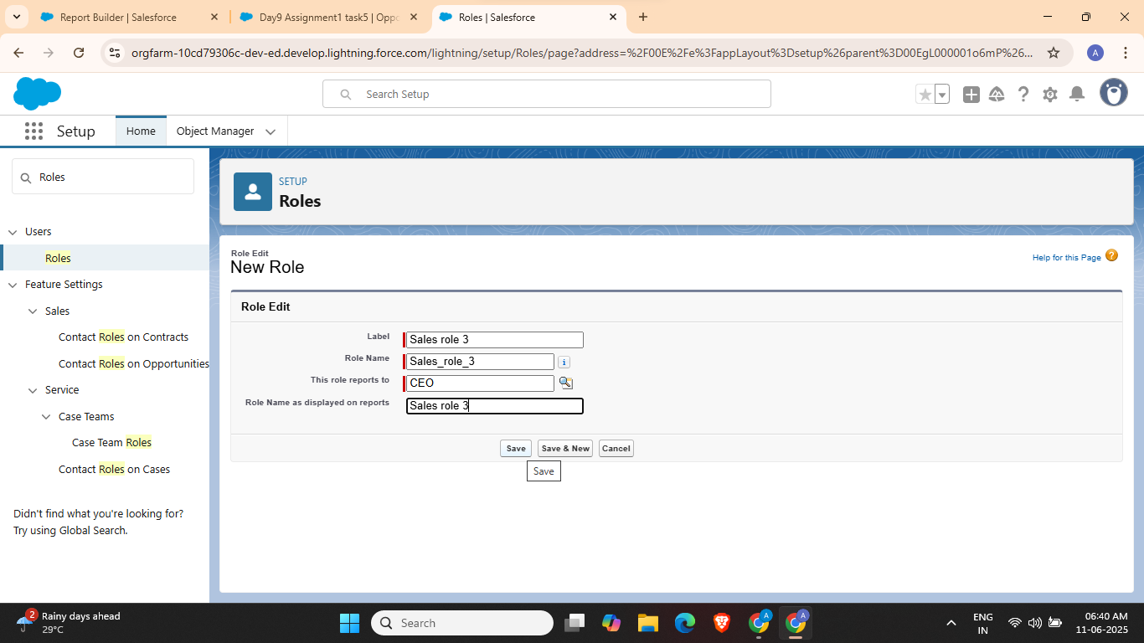

Task 2: Apply sharing rules for a custom object to demonstrate row-level security.

1. Go to Object Manager
2. 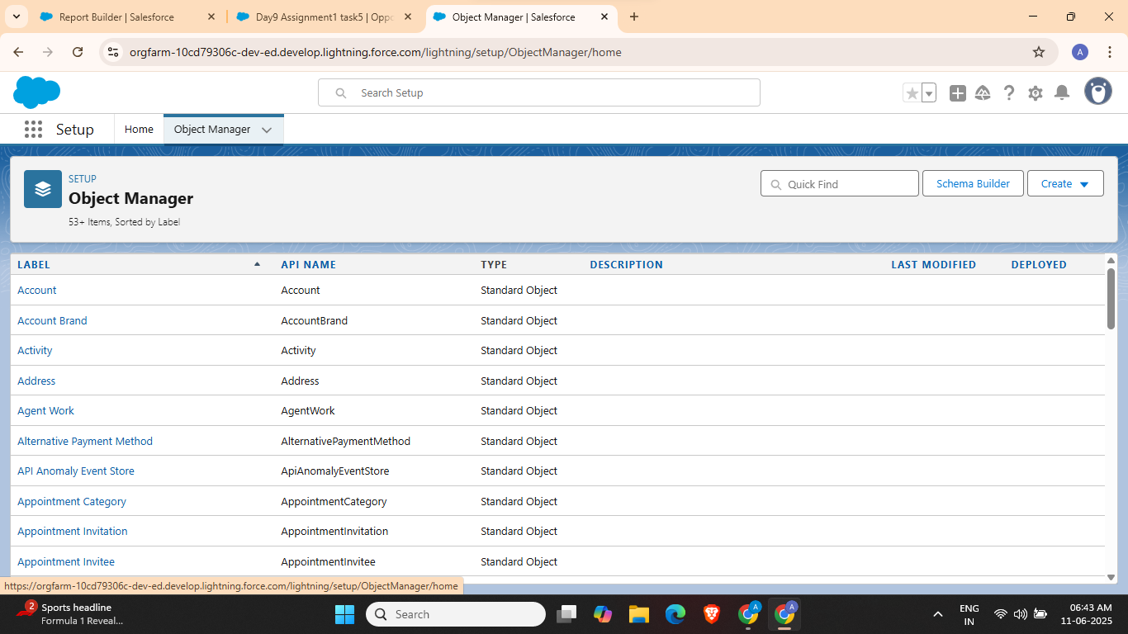
3. Click on Create > Custom Object
4. 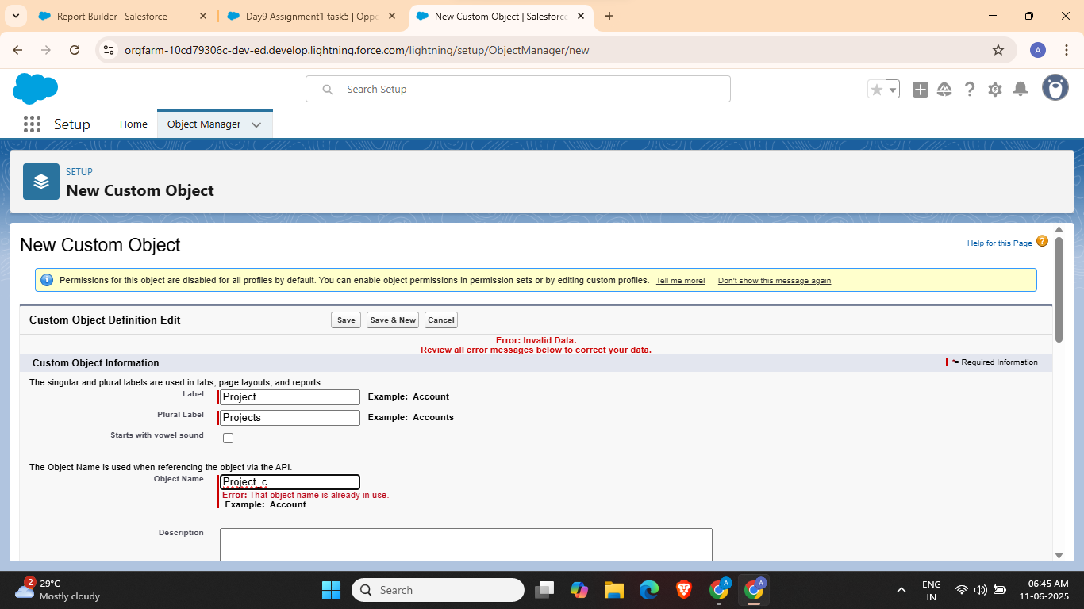
5. Go to Sharing Settings
6. 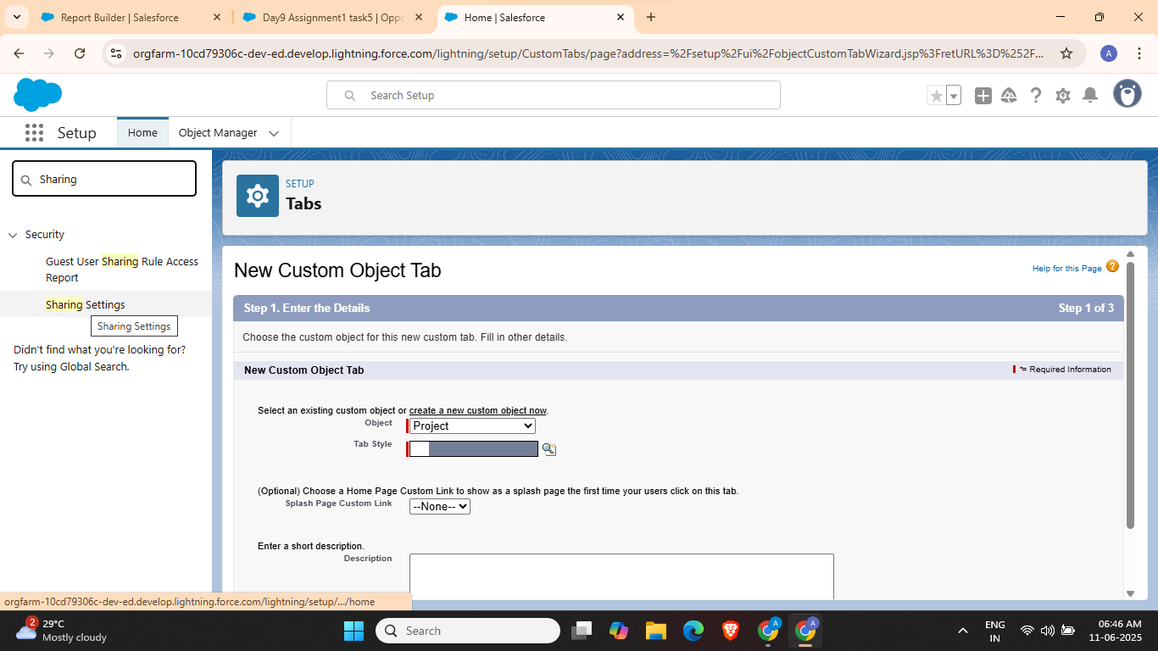
7. 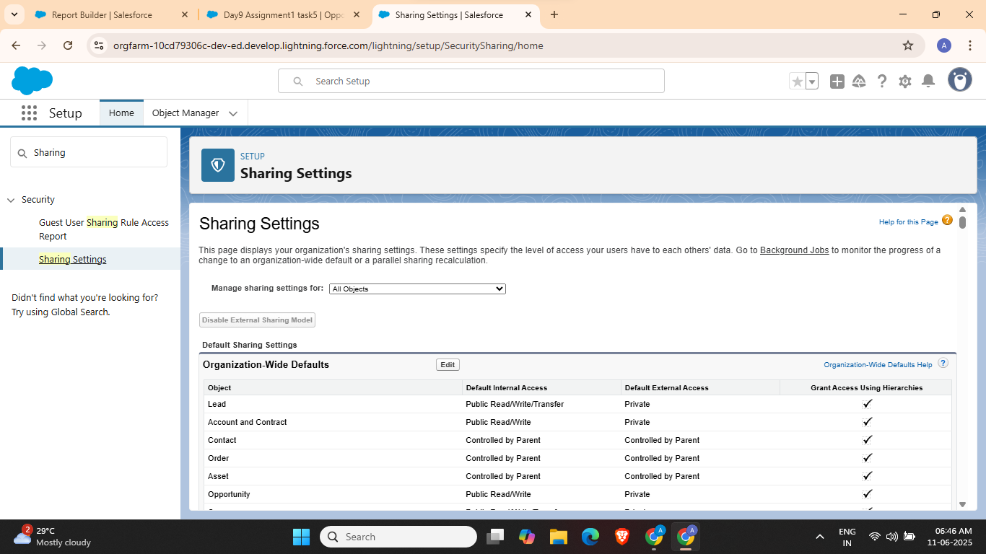
8. Set default internal access to Private
9. 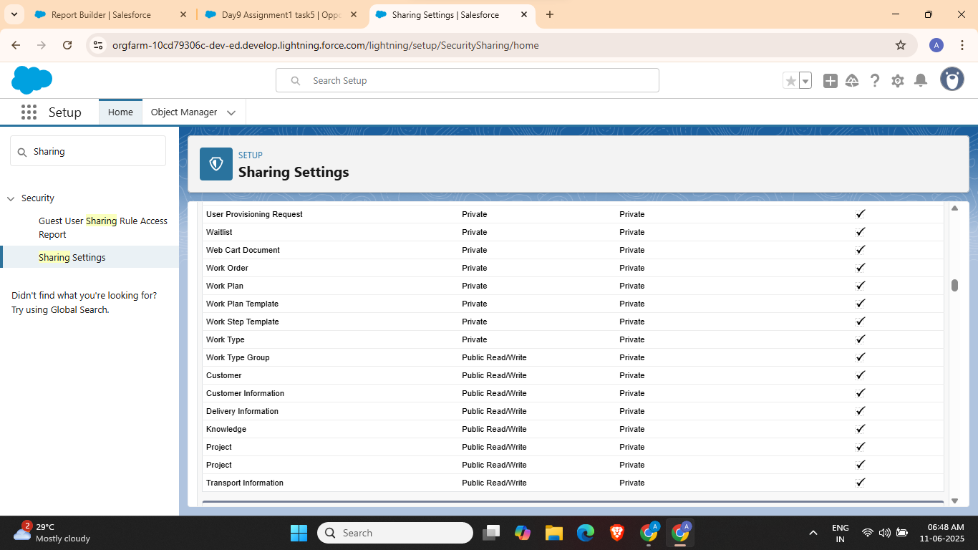
10. Scroll to Sharing rules and click new
11. 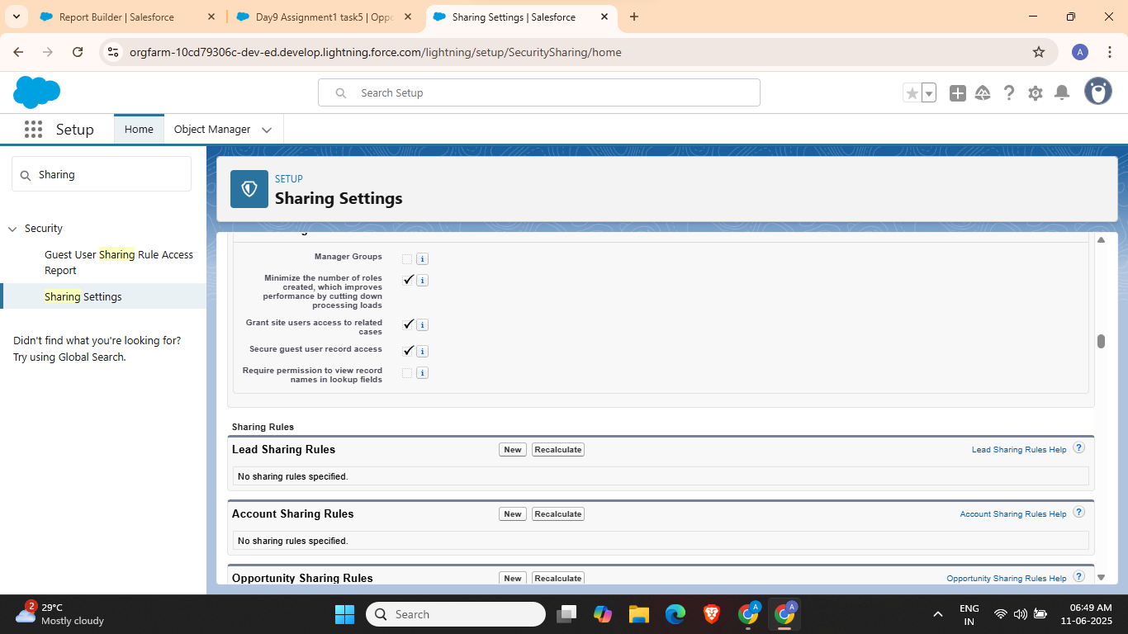
12. 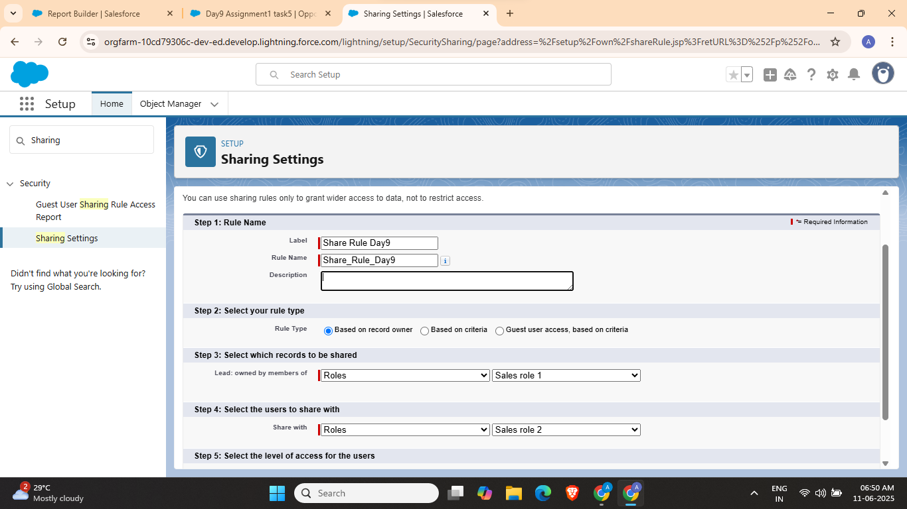

Task 3: Set field-level visibility restrictions for specific profiles (eg: hide revenue field for ‘Intern’ profile)

1. Go to Object Manager
2. 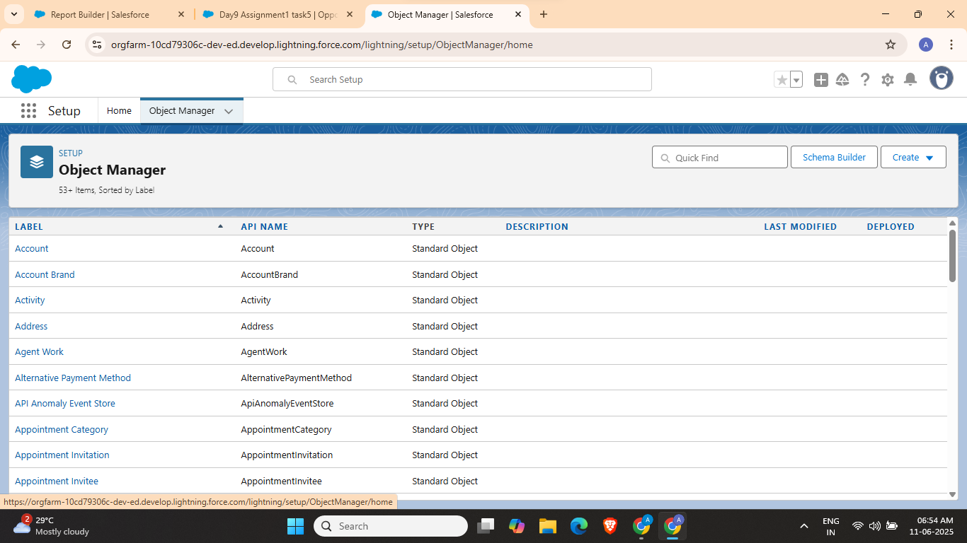
3. Select object Project_c
4. 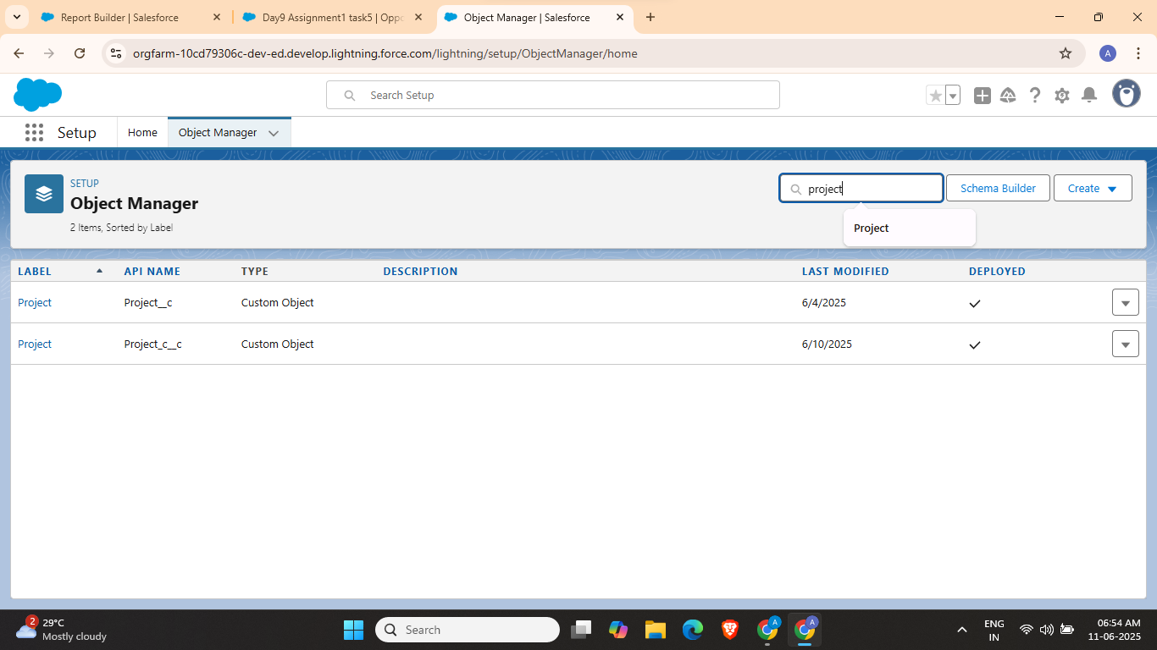
5. 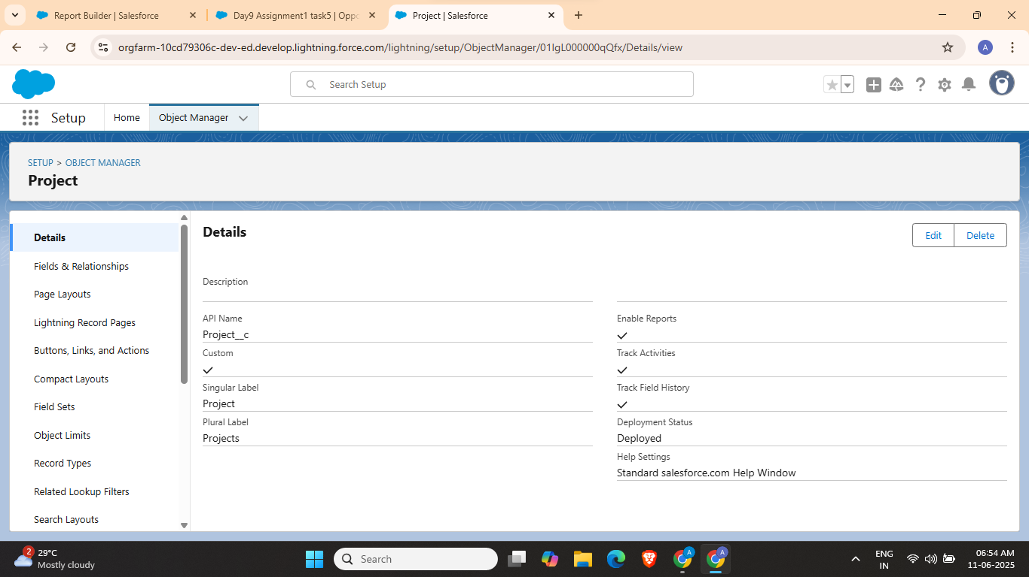
6. Select Status
7. 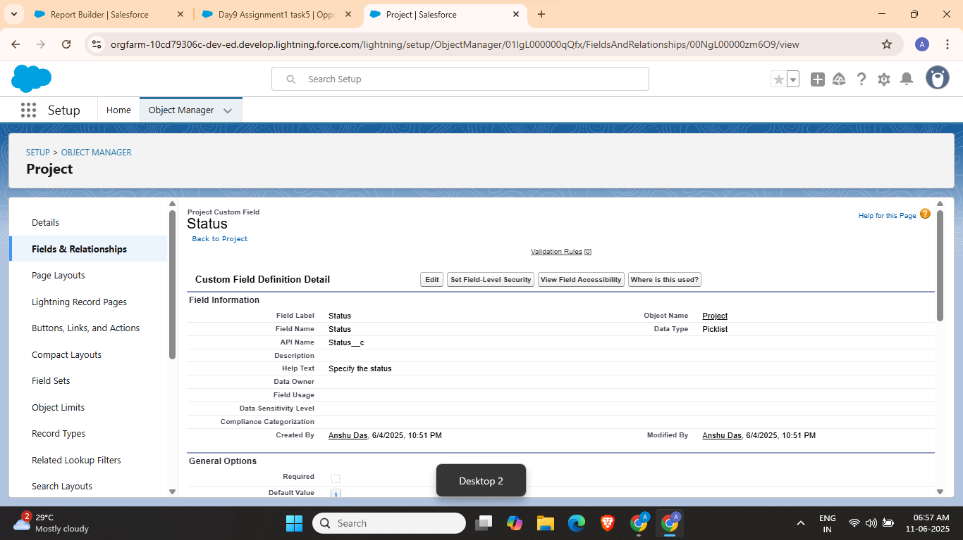
8. Click on Set Field-Level Security
9. 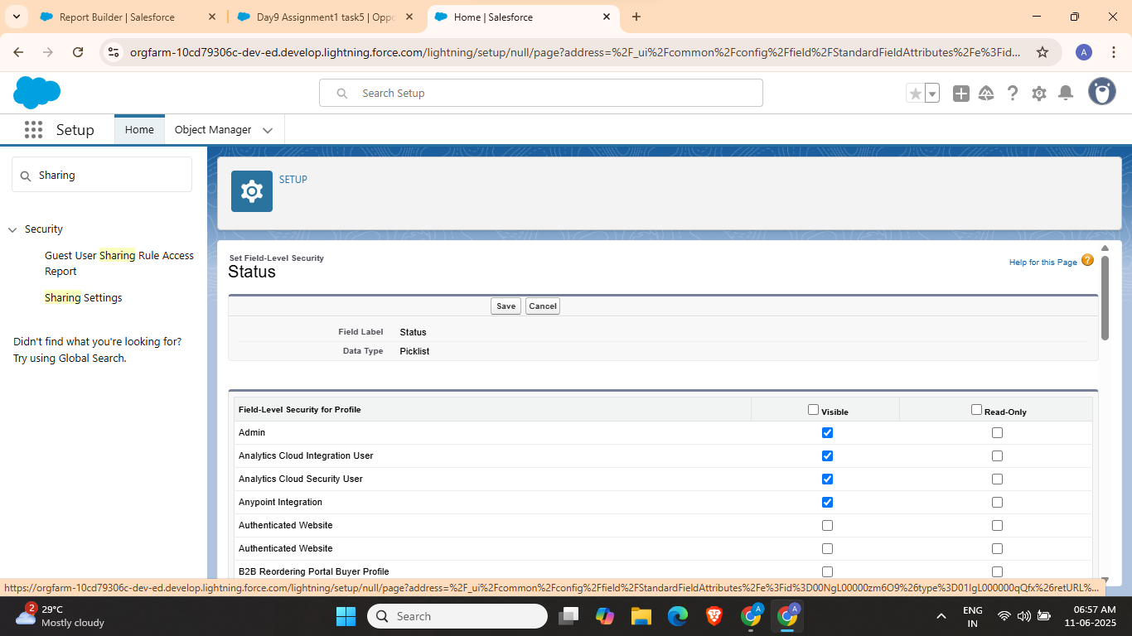
10. Uncheck visible for Marketing User profile
11. 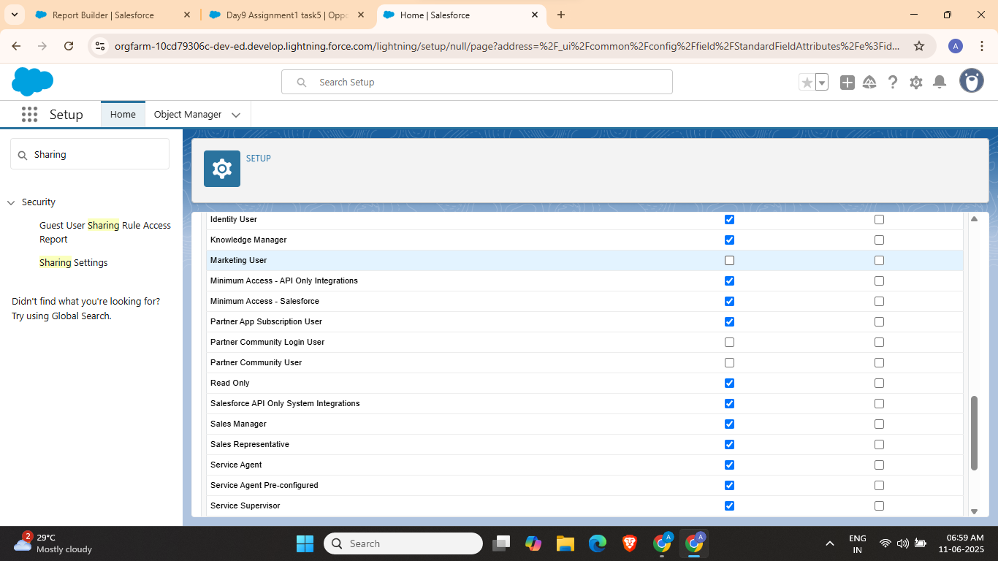
12. And Save

Task 4:

1. Search and open ‘Reports’ from the App Launcher
2. 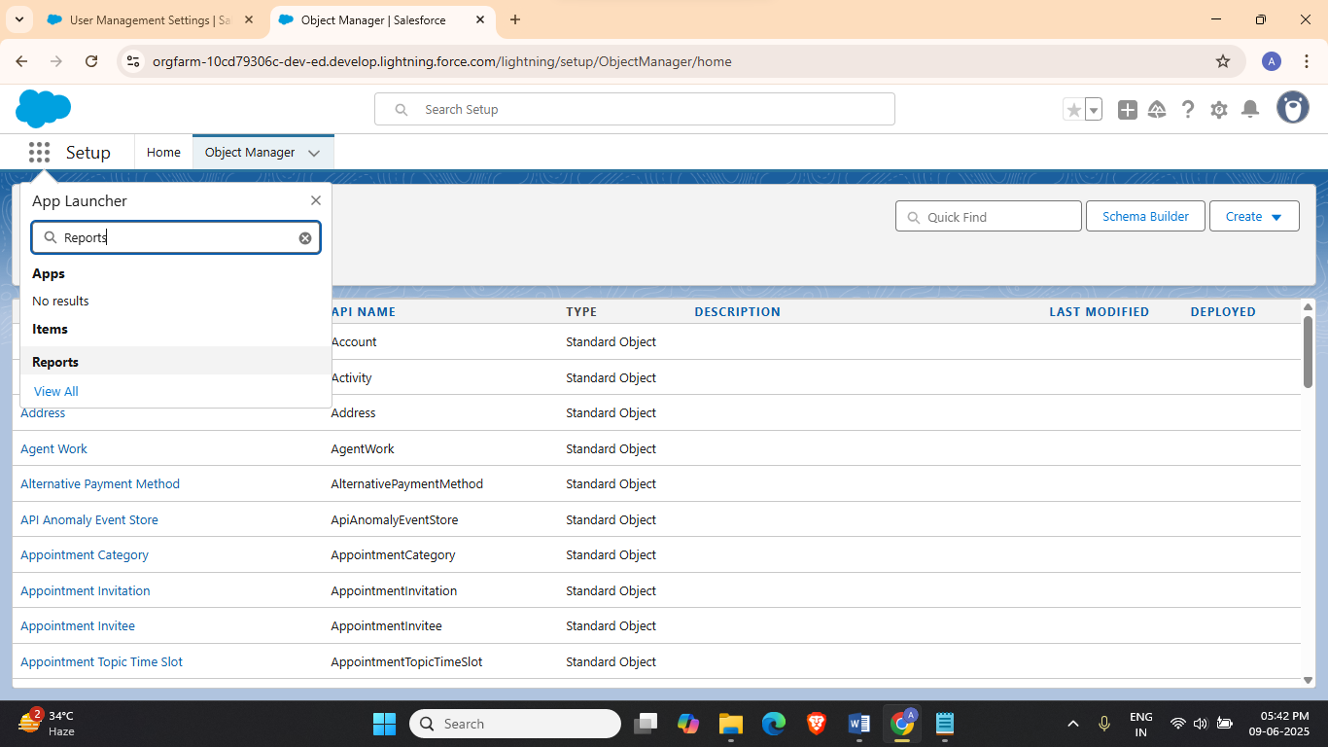
3. Click on New Report
4. 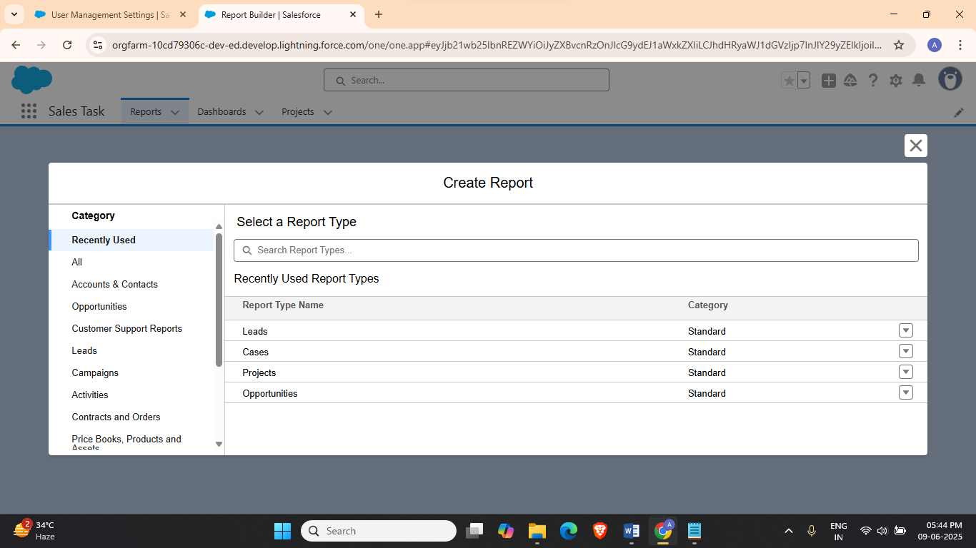
5. Click on Campaigns with Leads and ‘Start Report’
6. 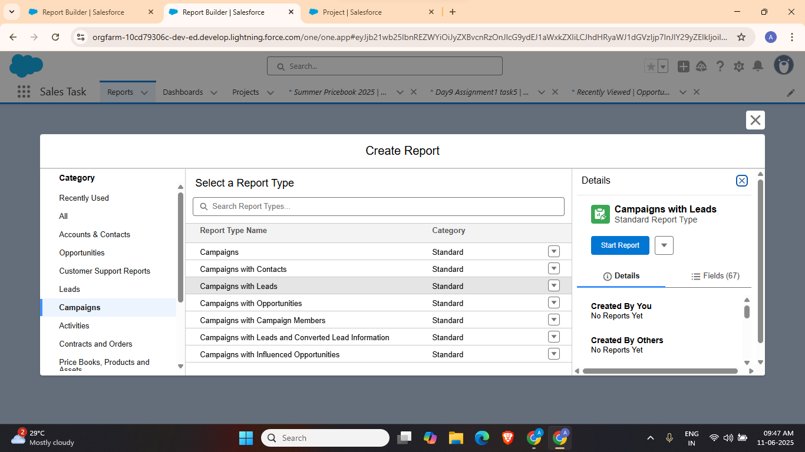
7. Group by Campaign name and create report
8. 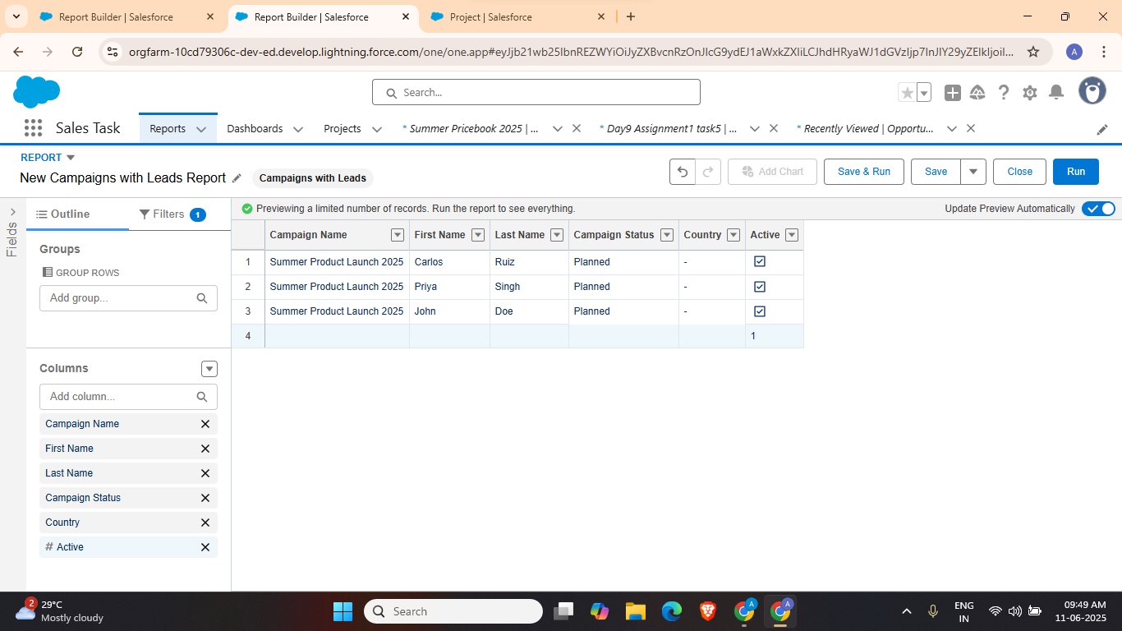
9. 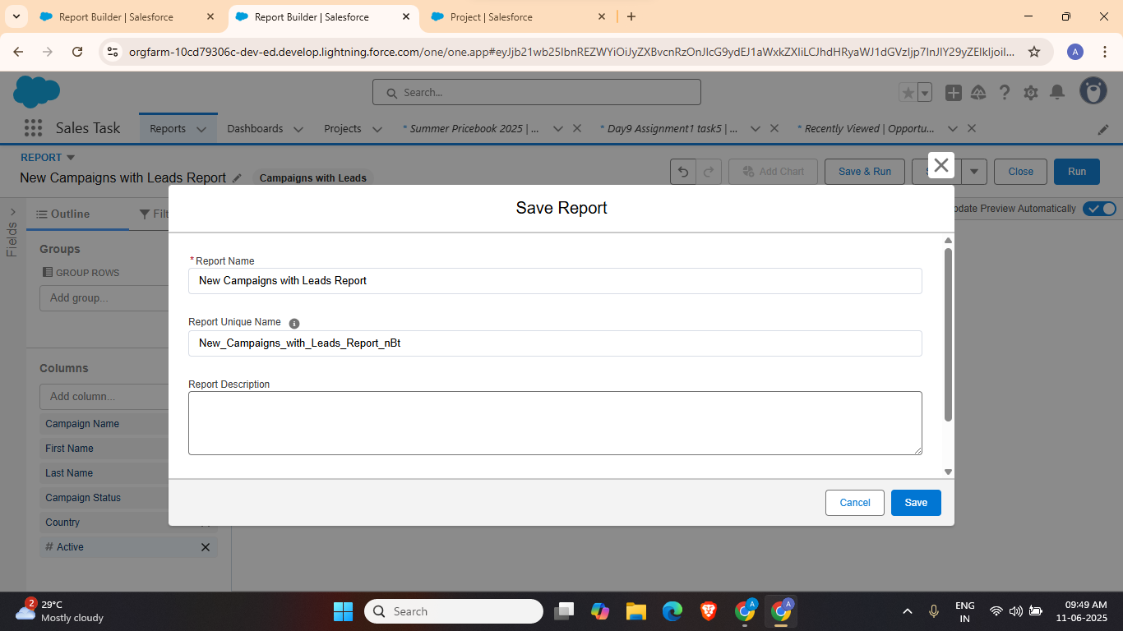
10. 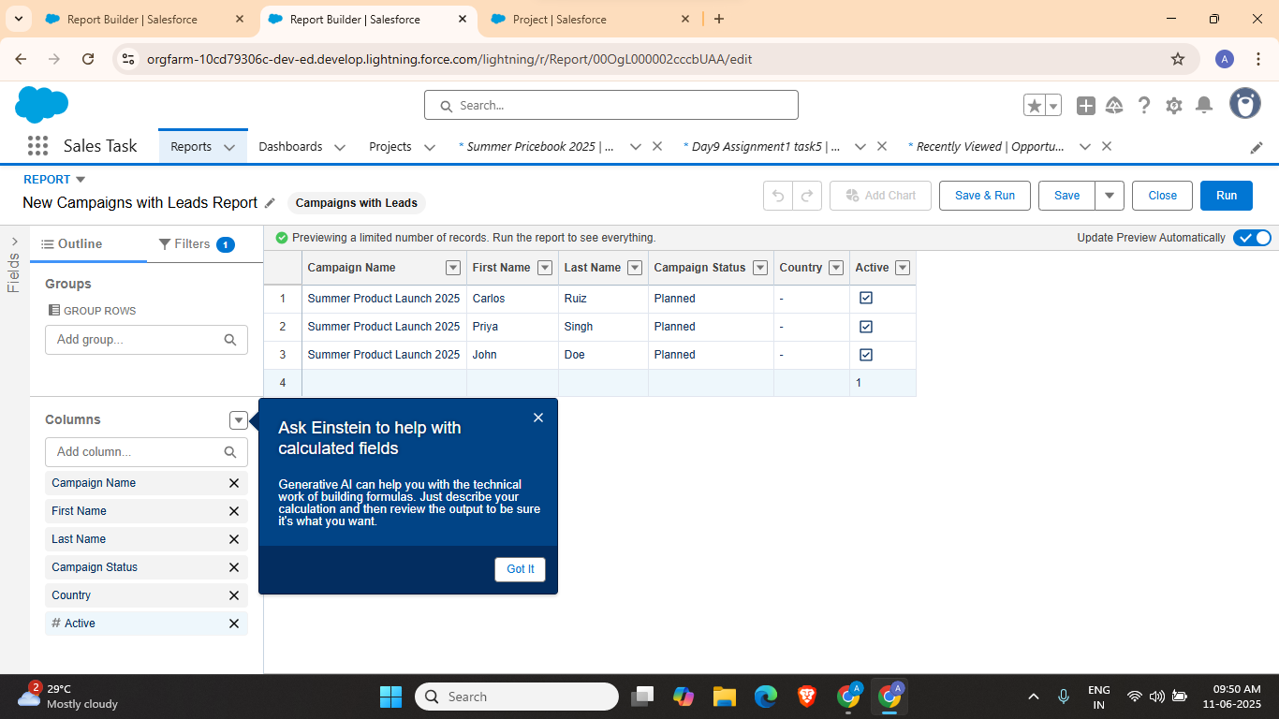
11. Now Create report for Opportunity grouped by Stage
12. 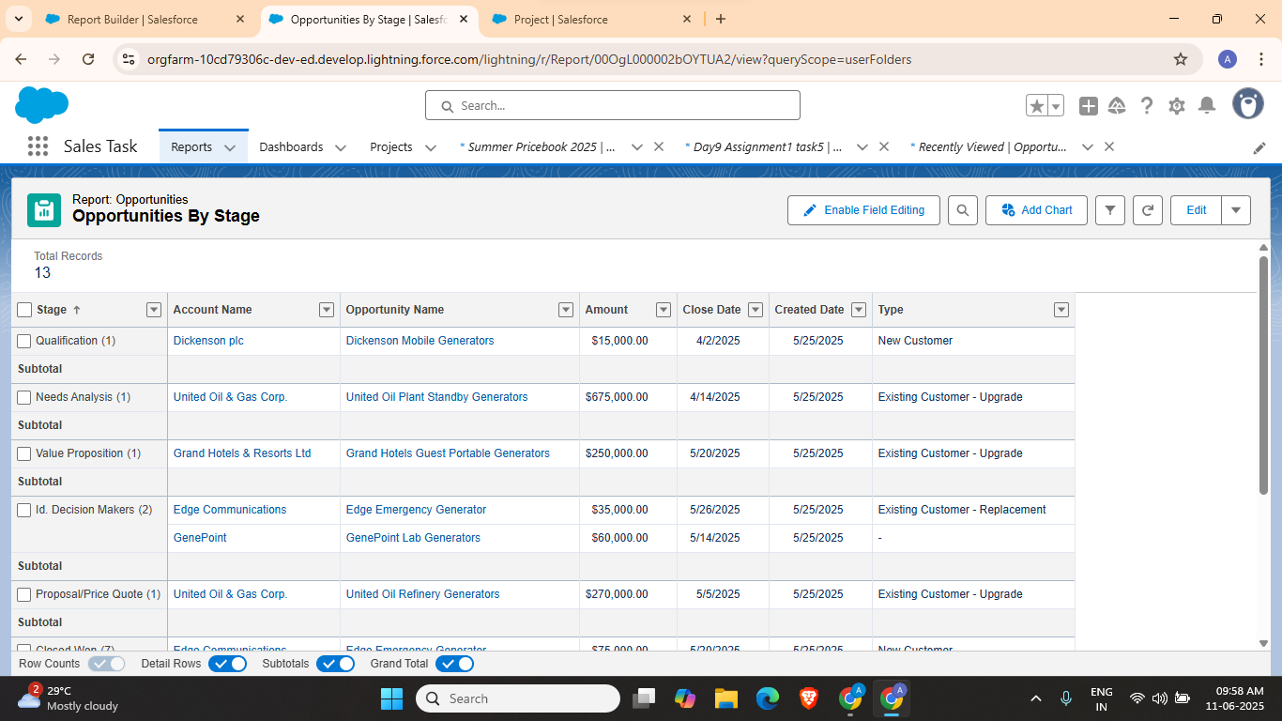

Task 5: Build a dashboard from the above reports and share it with a public group

1. Go to Dashboard and create a new dashboard
2. 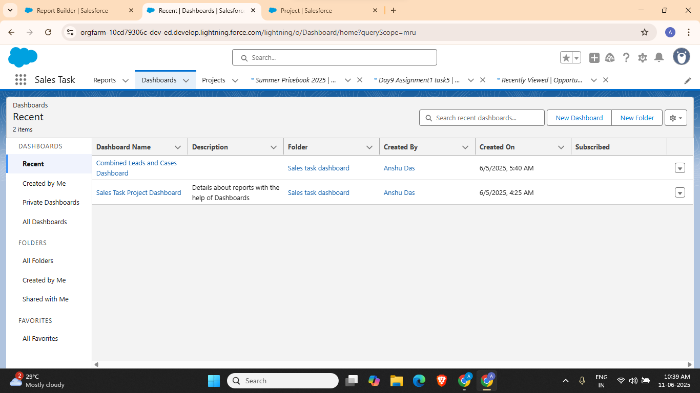
3. 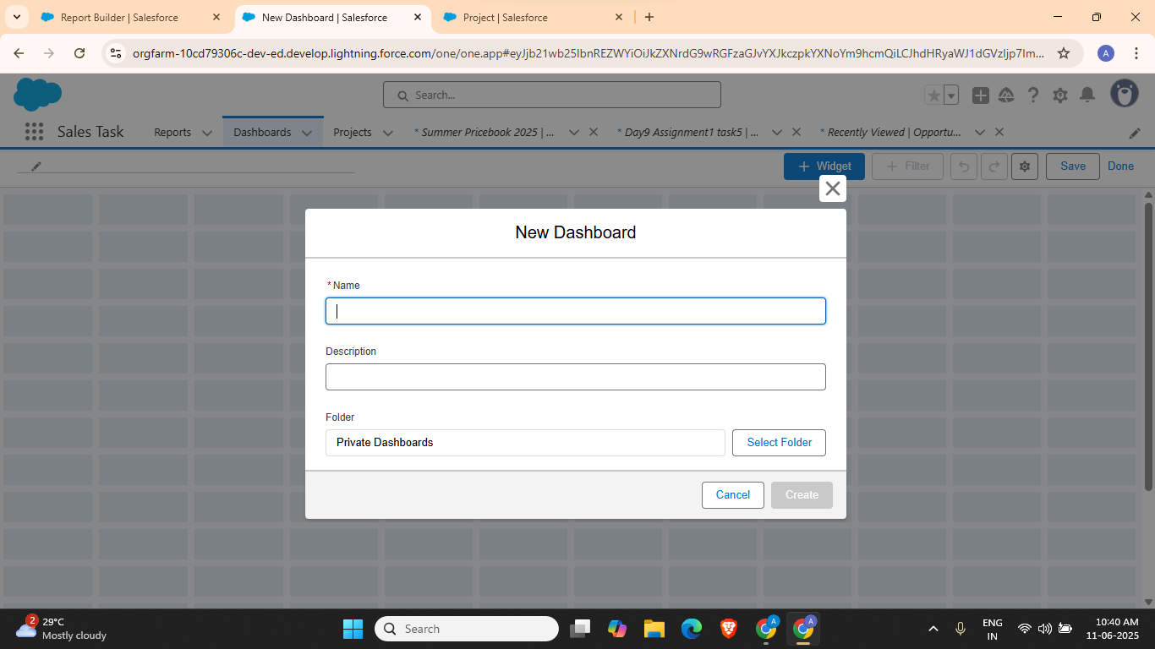
4. 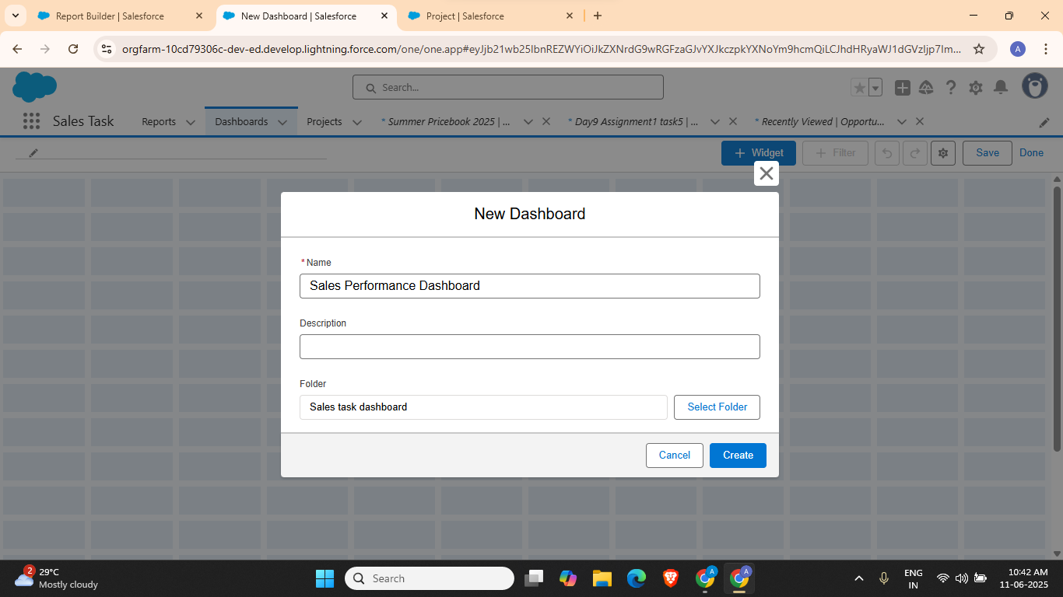
5. Click on Widget
6. 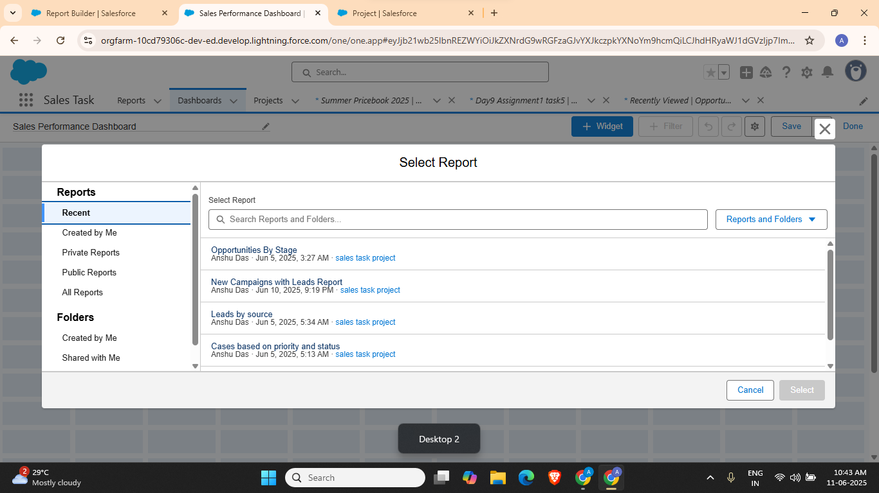
7. Select New Campaigns with Leads Report and Opportunity by stage
8. 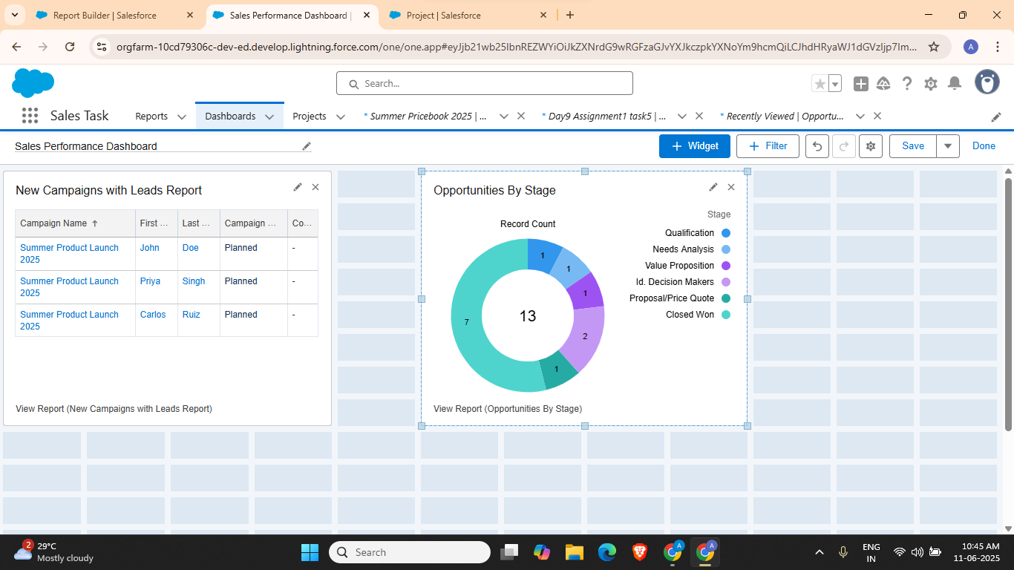

Task 6:

1. Go to Quick Find and search for ‘Data import wizard’
2. 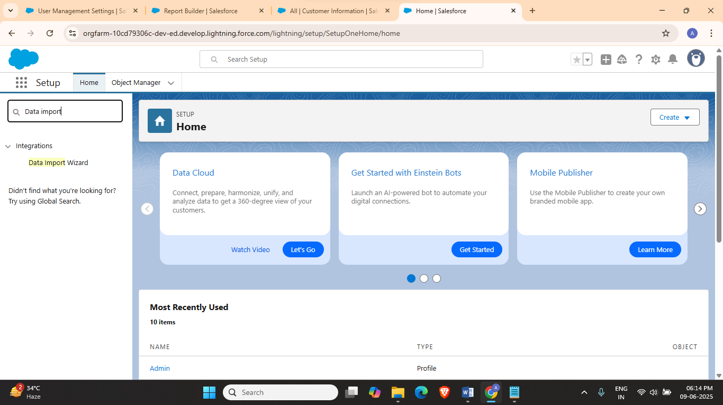
3. Click on Data Import Wizard and scroll down
4. 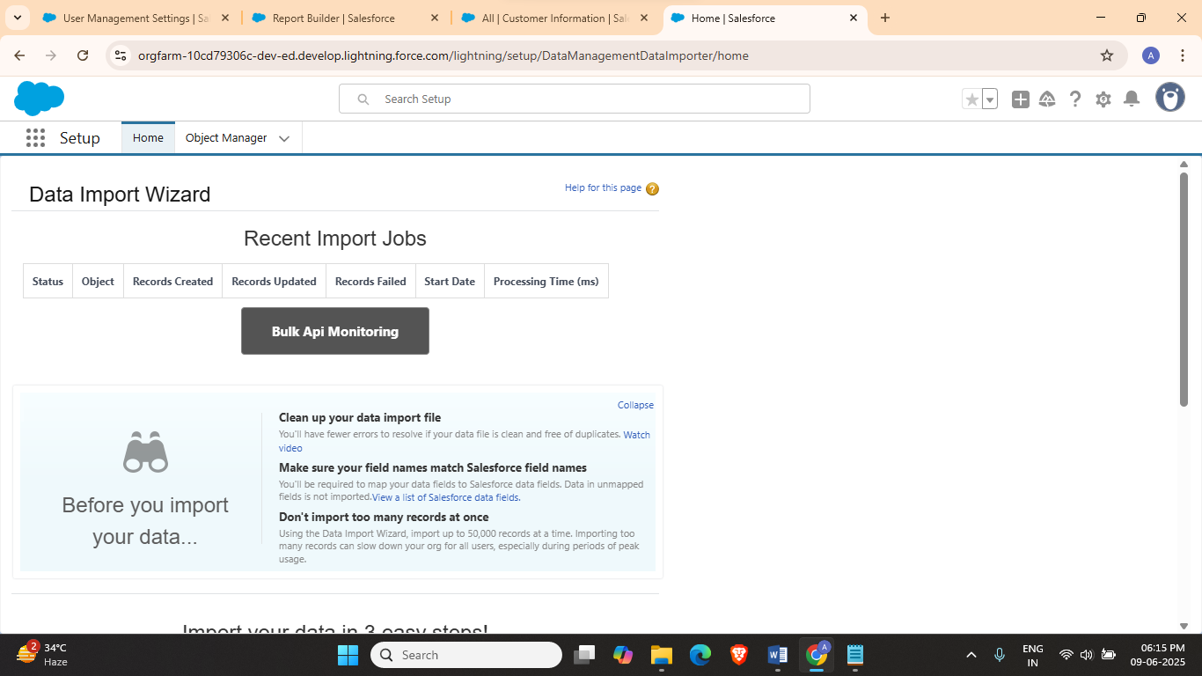
5. Click on ‘Launch Wizard’
6. 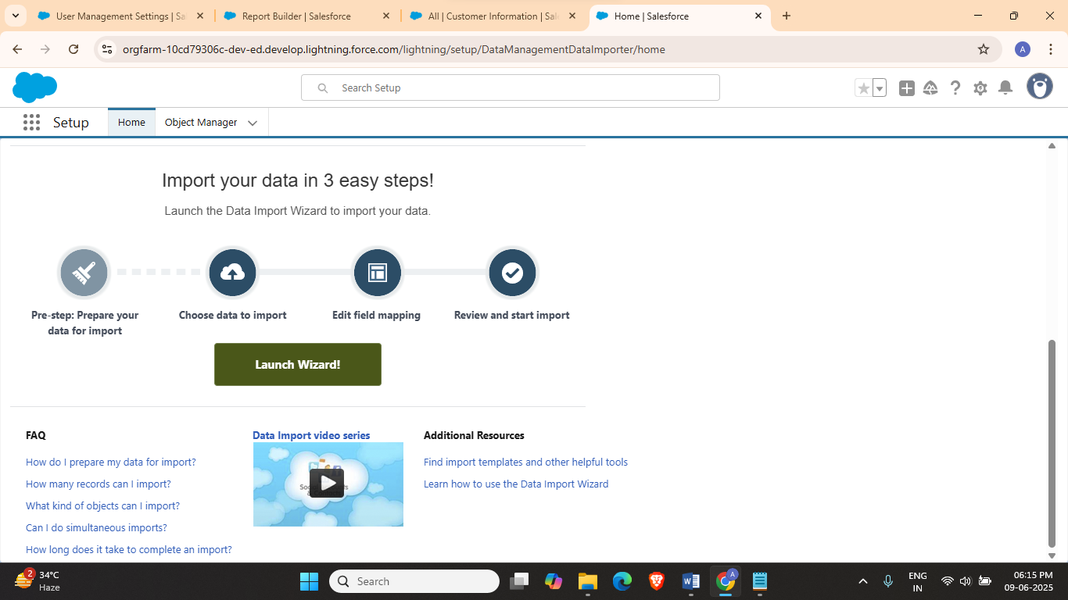
7. Select Custom Object
8. 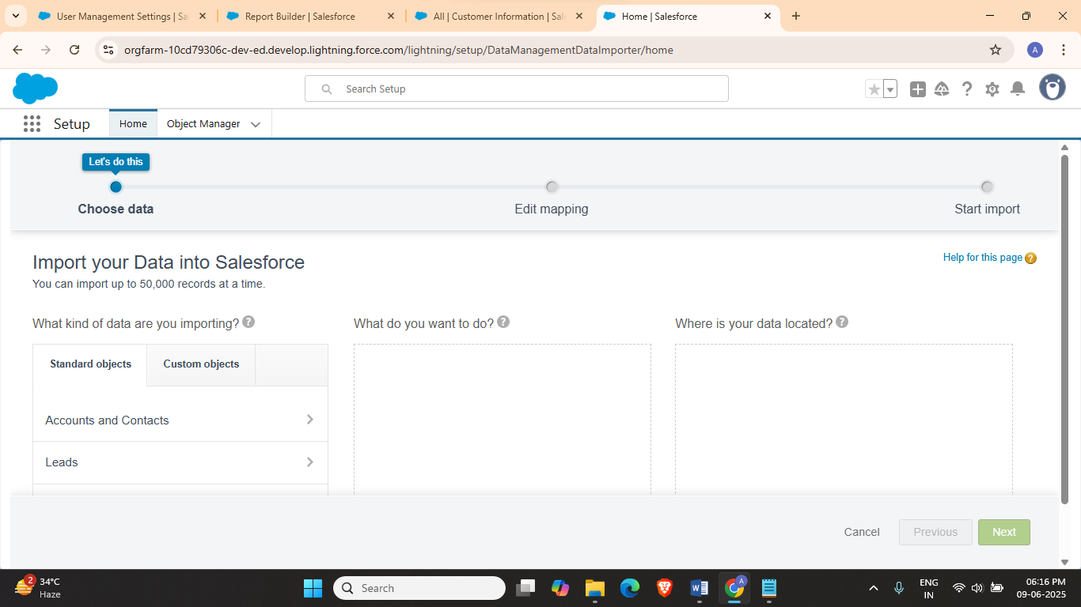
9. Select Customer Information
10. 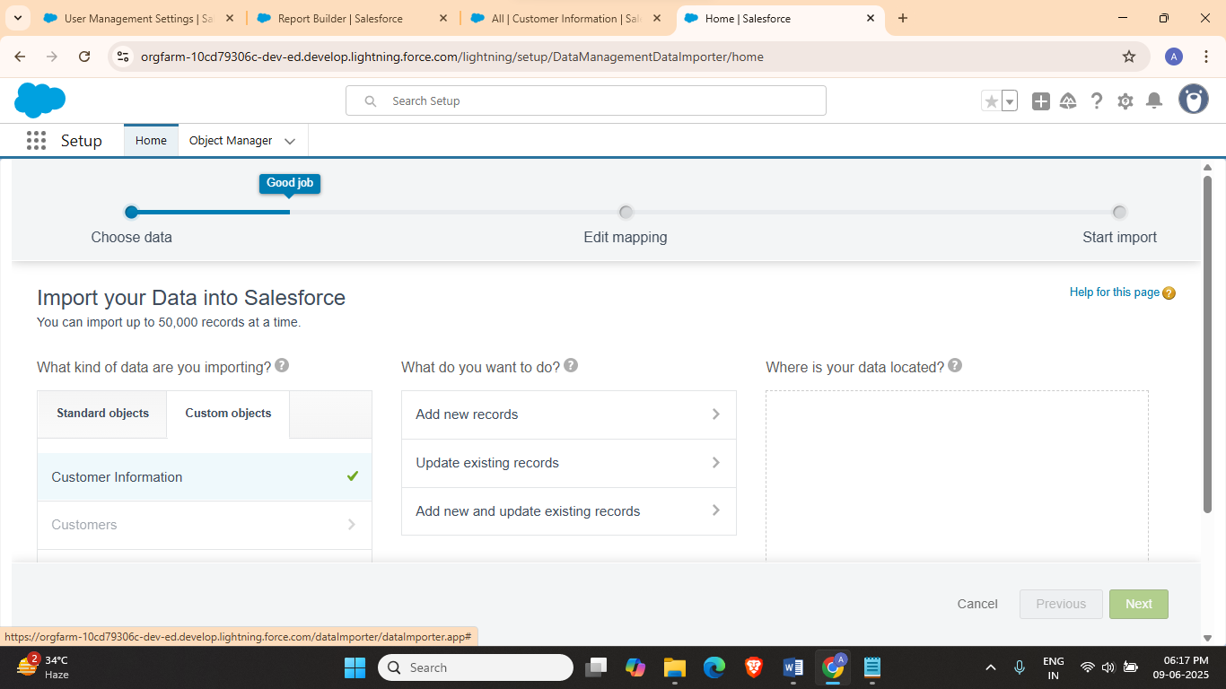
11. Select Add new records
12. 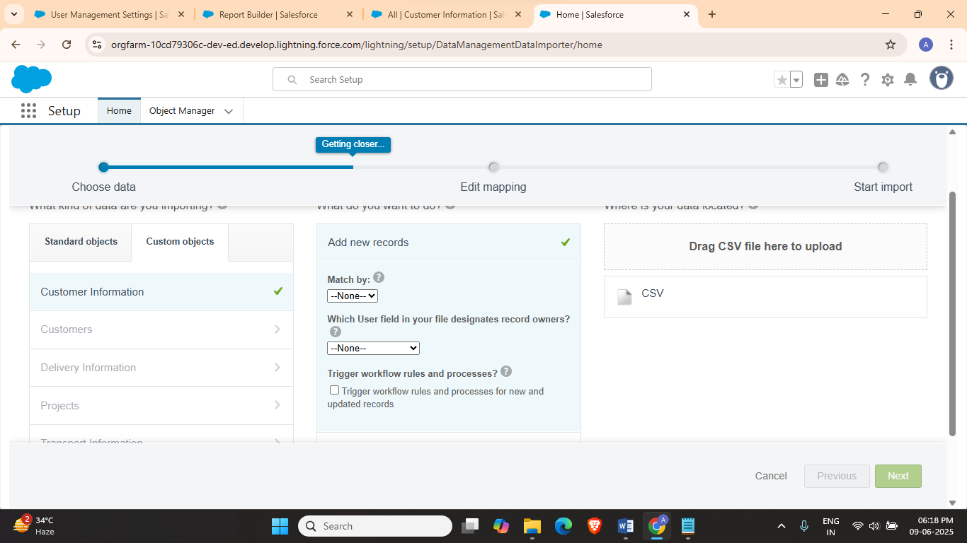
13. Select CSV
14. 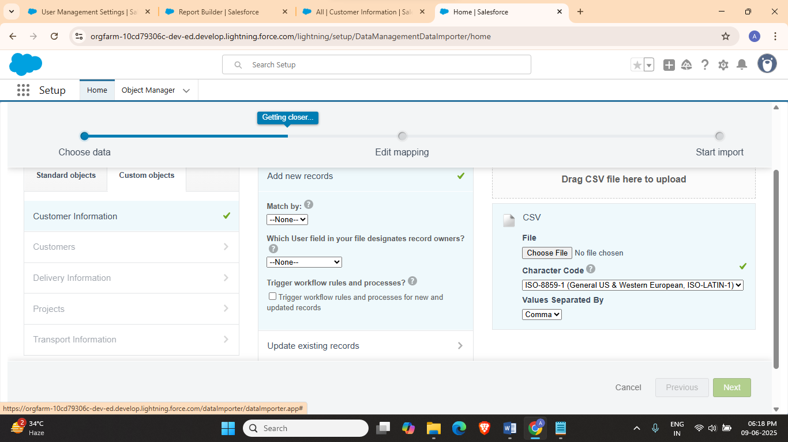
15. Click on Choose a file
16. 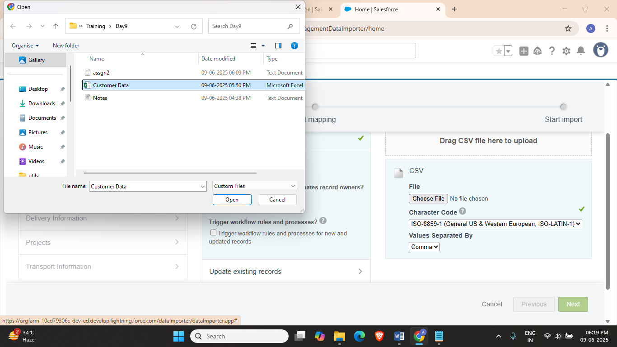
17. Click on Next